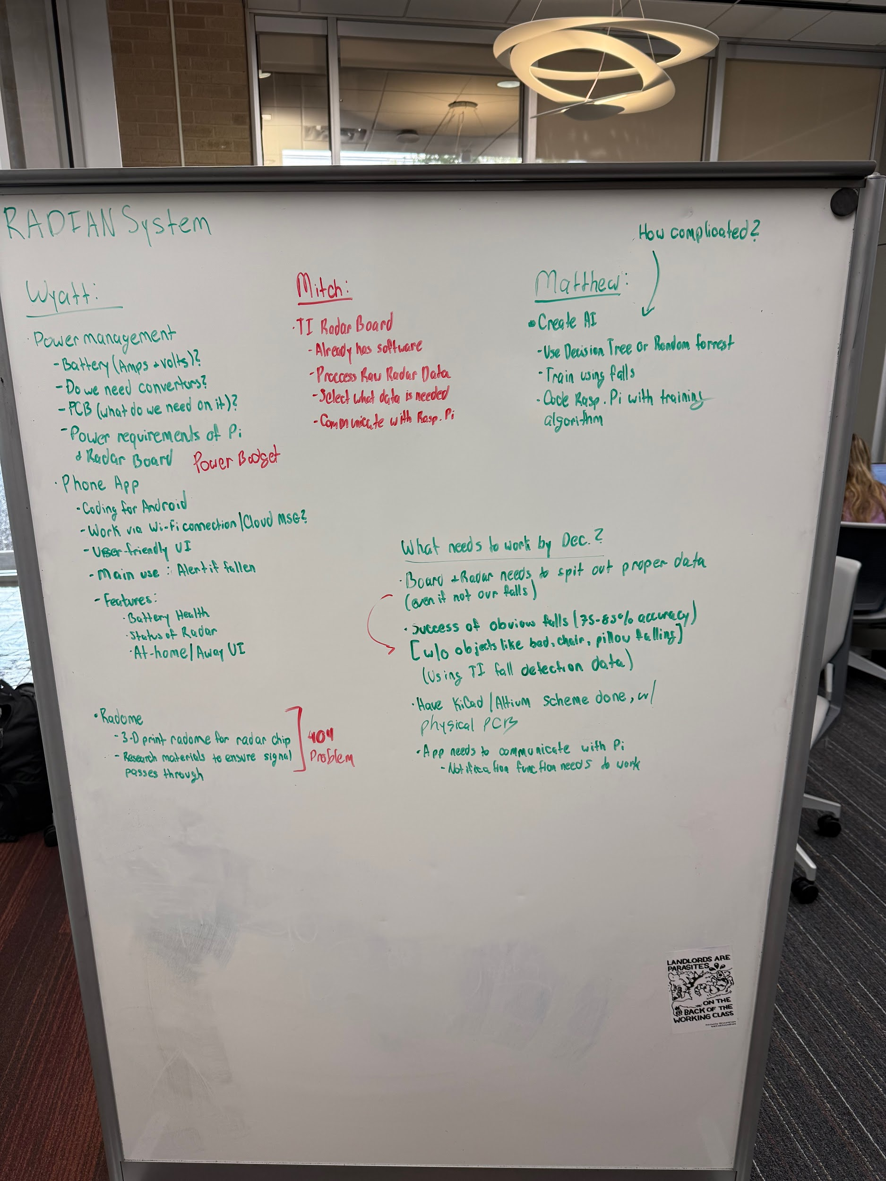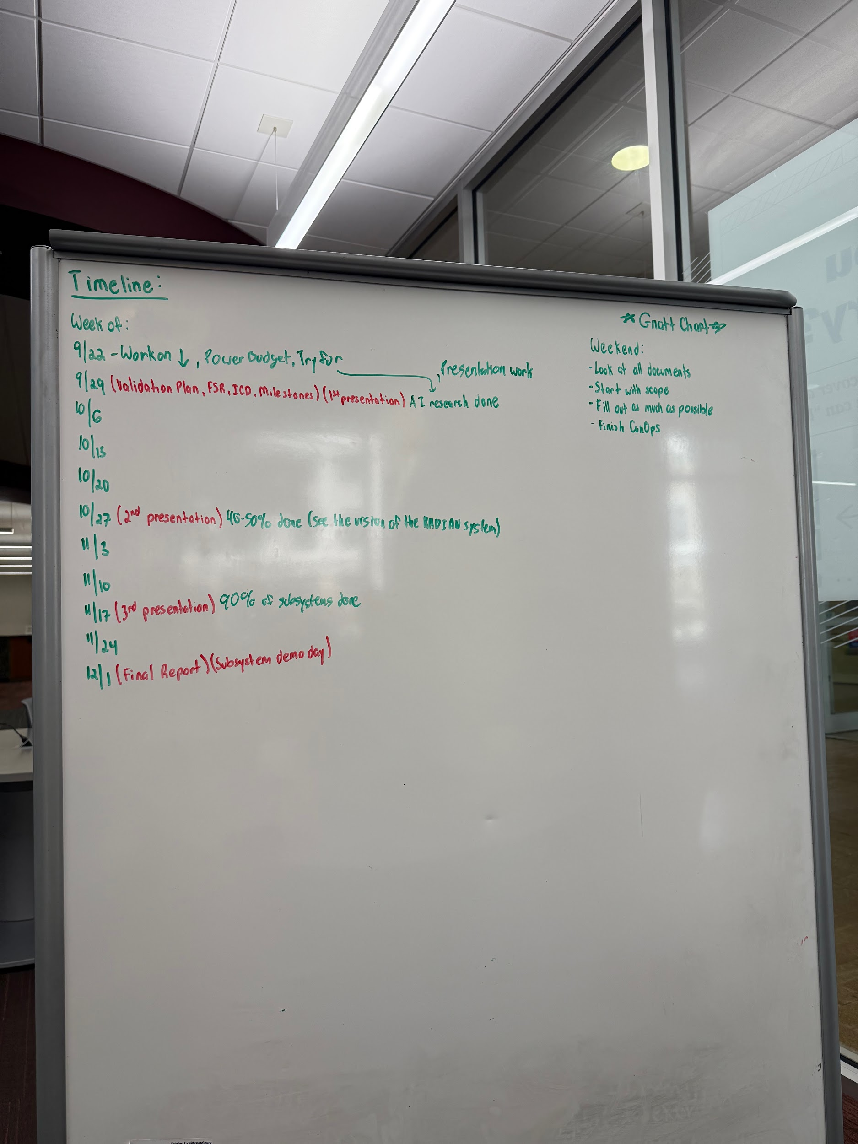
Went through a general overview of our system once again, highlighting what each person is responsible for over the course of 403. We also have 4 objectives that we would like to accomplish by the end of 403, so that we can stay on track and plan around those. We made a rough timeline for the whole of the system.

Each of these items is shown on the two images above.

